
TITANIC SURVIVAL PREDICTION
MACHINE LEARNING PROJECT
BCA(AI)
SECTION A

PROGRAM CODE: IIOT-4
PROGRAM NAME: MACHINE LEARNING
PROJECT NAME: Titanic Survival Prediction
MENTOR NAME: HARSH SHRIVASTAV
DEPARTMENT OF COMPUTER SCIENCE AND ENGINEERING

COURSE NAME: BCA(AI)
TEAM MEMBERS: | STUDENT ID:
Gurmeet Singh (Team Leader) | BCAI2025032
[Student Name 2] | [Student ID]
[Student Name 3] | [Student ID]
[Student Name 4] | [Student ID]
[Add or remove rows as required]
Section: A

Submission Date: [Submission Date]
INDEX
System Architecture Diagram 04
1. Introduction 05
2. Problem Statement 06
3. Objectives of the Project 07
4. Methodology 08
5. Literature Review 12
6. Explanation of the Project (Working) 13
7. Workflow 15
8. Program 17
9. Results and Discussions 20
10. Snippets of UI 28
11. Future Scope 30
12. Conclusion 31
References 32
Appendices (A to C) 33
System Architecture Diagram
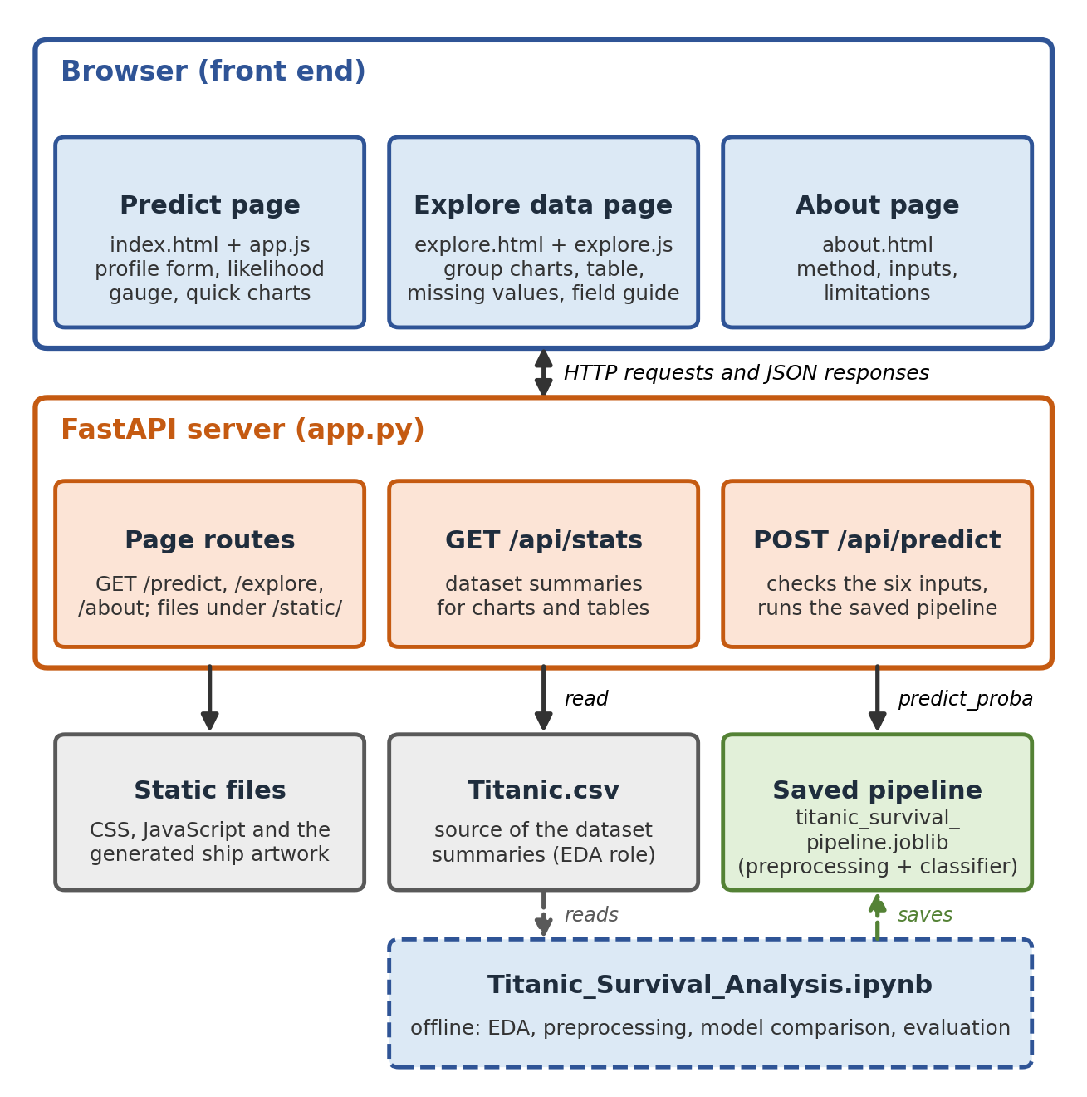
Figure 1: System architecture of the Titanic Survival Prediction project.
The browser front end consists of three pages (Predict, Explore data and About). They communicate with a FastAPI backend (app.py) through page routes and two JSON endpoints: GET /api/stats for dataset summaries and POST /api/predict for survival estimates. The prediction endpoint uses a saved scikit-learn pipeline (titanic_survival_pipeline.joblib) that bundles preprocessing and the classifier. Titanic.csv supplies the dataset summaries shown on the website and is the source data for the notebook, which is run offline to analyse the data, compare models and save the pipeline.

1. Introduction
The RMS Titanic was a British passenger liner that sank in the North Atlantic on 15 April 1912, during its maiden voyage from Southampton, after striking an iceberg. Passenger records from the voyage are widely used as a beginner-friendly dataset for learning data science and machine learning.
This project uses a Titanic passenger file, Titanic.csv, which contains 891 passenger records and 15 passenger columns, plus an unnamed row-index column. The columns describe each passenger's ticket class (pclass), sex, age, the number of siblings or spouses (sibsp) and parents or children (parch) travelling with them, the ticket fare, and the port of embarkation (embarked), together with the recorded outcome survived. The file also contains several text or derived columns (class, who, adult_male, deck, embark_town, alive and alone) that are analysed in Section 4.6. The file has no passenger names, ticket numbers or cabin numbers, so every analysis in this report uses only the columns that are actually present.

1.1 Machine Learning Objective
The objective is to train a supervised machine learning model that learns, from records whose outcome is known, the relationship between passenger attributes and survival, and then uses that relationship to estimate the survival outcome for a described passenger. The project also packages the trained model behind a small web application so that the estimate can be explored interactively.

1.2 Binary Classification and the Target Variable
A classification problem asks a model to assign each case to one of several categories. When there are exactly two categories, the problem is binary classification. Here the target column is survived:
Table 1: The binary target variable survived.
Value of survived | Meaning | Records in the dataset
0 | The passenger did not survive | 549 (61.6%)
1 | The passenger survived | 342 (38.4%)

Because the model outputs a probability between 0 and 1, a predicted probability of at least 0.5 is interpreted as the class “survived”.

1.3 Educational Purpose
The project is an educational exercise. It demonstrates a complete and careful machine learning workflow: validating a dataset, exploring it visually, preventing target leakage, engineering a feature, building leak-free preprocessing pipelines, comparing models against a baseline, evaluating them on held-out data, saving a complete pipeline, and connecting it to a web interface. It is not a clinical, safety or operational system.

1.4 Project Components
The project consists of the data file Titanic.csv, the Jupyter notebook Titanic_Survival_Analysis.ipynb, the saved pipeline titanic_survival_pipeline.joblib created by the notebook, the FastAPI backend app.py, and the website files in the static/ folder (Predict, Explore data and About pages with their scripts and styles); see Section 6.3.

2. Problem Statement
The problem addressed in this project is to predict a passenger's recorded survival outcome (survived or did not survive) from the passenger attributes that are available in the dataset: ticket class, sex, age, family size (derived from sibsp and parch), ticket fare and port of embarkation.
Solving this problem requires more than fitting a model. The data contain missing values (most notably in age), columns that duplicate or reveal the target, and groups of very different sizes. A trustworthy solution must therefore handle missing data correctly, avoid target leakage, keep validation data separate from every fitting step, and report performance on records that the model has not seen.

2.1 Project Scope
- Analysing and visualising the passenger records in Titanic.csv.
- Training and comparing three classifiers against a no-skill baseline.
- Saving a single pipeline that accepts the six website inputs and returns a survival probability.
- Providing a web interface with prediction, data exploration and project explanation pages.

2.2 What the Prediction Does Not Claim
- It does not state what would actually have happened to any real person.
- It does not show that any attribute caused survival; the analysis only measures statistical associations in one historical dataset.
- It does not generalise to other voyages, disasters or populations.
- It is not a medical, safety or operational decision tool.
- The probability shown on the website is an estimate. The model behind the demo is fitted on all rows, so that probability is not a held-out test score (see Sections 4.9 and 9.10).

3. Objectives of the Project
The concrete objectives of this project are:
- To inspect and validate the Titanic dataset: its shape, column names, data types, duplicate rows and missing values.
- To perform exploratory data analysis (EDA) of survival by sex, passenger class, age, fare, embarkation port and family size.
- To identify and exclude columns that leak the target (alive) or duplicate other information (class, who, adult_male, alone, embark_town).
- To prepare features, including the derived feature family_size = sibsp + parch + 1, using leak-free scikit-learn pipelines.
- To train a baseline and three classifiers (Logistic Regression, Decision Tree and Random Forest) and compare them fairly with cross-validation on the training data.
- To evaluate the models on a stratified validation set using accuracy, precision, recall, F1 score and ROC-AUC, and to examine the confusion matrix.
- To interpret the selected model cautiously, separating association from causation.
- To save a complete preprocessing-plus-model pipeline with joblib for use by the backend.
- To present the results through a FastAPI web application with Predict, Explore data and About pages.

4. Methodology
The project follows a structured machine learning workflow. Each stage below corresponds to a section of the notebook Titanic_Survival_Analysis.ipynb, and all numbers quoted in this report were produced by running that notebook.

4.1 Dataset and Data Collection
The data come from the supplied file Titanic.csv, with 891 rows and 16 columns (15 passenger columns and one unnamed index column). Table 2 lists every column, its type, the number of missing values and how it is used in the project. The file does not contain Name, Ticket or Cabin columns, so none of these is used or invented.
Table 2: Column inventory of Titanic.csv (the unnamed index column has no missing values).
Column | Type | Missing | Use in this project
Unnamed: 0 | integer | 0 | Row index; removed (not a passenger trait)
survived | integer (0/1) | 0 | Target
pclass | integer (1, 2, 3) | 0 | Model input (categorical)
sex | text | 0 | Model input (categorical)
age | decimal | 177 | Model input (imputed)
sibsp | integer | 0 | Combined into family_size
parch | integer | 0 | Combined into family_size
fare | decimal | 0 | Model input
embarked | text (S, C, Q) | 2 | Model input (categorical, imputed)
class | text | 0 | Excluded: duplicates pclass
who | text | 0 | Excluded: derived from age and sex
adult_male | boolean | 0 | Excluded: derived
deck | text | 688 | Excluded: 77.2% missing
embark_town | text | 2 | Excluded: duplicates embarked
alive | text (yes/no) | 0 | Excluded: target leakage
alone | boolean | 0 | Excluded: derived

The column names (for example class, who, adult_male, embark_town, alive and alone) resemble the Titanic dataset distributed with the Seaborn visualisation library, but the project files do not record where Titanic.csv was obtained or under which licence, so this must be confirmed by the team.

4.2 Data Validation and Preprocessing
Before any analysis the notebook loads the file from the project folder and performs explicit checks rather than assuming the structure of the data:
- The shape, first rows, column names, data types and descriptive statistics are displayed.
- The unnamed column is checked and confirmed to be exactly the row numbers 0 to 890; it is then dropped so that it cannot be used as a feature.
- The notebook asserts that the target and all required model columns exist and that the target contains only the values 0 and 1.
- 107 rows are exact duplicates across all remaining columns. Because the file has no passenger identifier or name, it is not possible to tell whether these are accidental copies or different passengers who share identical recorded values (for example, single travellers in the same class who paid the same fare). The rows were therefore kept rather than silently deleted.

4.3 Missing-Value Analysis and Imputation
Table 3: Columns with missing values.
Column | Missing values | Share of rows | Handling
age | 177 | 19.9% | Median imputation inside the pipeline
embarked | 2 | 0.2% | Most-frequent imputation inside the pipeline
embark_town | 2 | 0.2% | Column not used
deck | 688 | 77.2% | Column not used

Missing numeric values (age) are replaced by the median of the training data, which is robust to extreme values. Missing categories (embarked) are replaced by the most frequent training category. These steps are part of the scikit-learn pipeline, so they are learned only from training rows. The notebook demonstrates this: the age median learned by the imputer is 28.5, which equals the training-set median (28.5) and differs from the validation-set median (27), confirming that validation data did not influence the fitted imputer.

4.4 Exploratory Data Analysis
Exploratory data analysis (EDA) examines the data visually before any modelling. The notebook produces labelled charts, each with group sizes where relevant, for: target class counts; survival by sex and passenger class; the age distribution and survival by age group; the fare distribution (including a log-scale view) and survival by fare quartile; survival and passenger counts by embarkation port; survival by family size; and the missing-value pattern. The charts are presented in Section 9 together with their interpretation and caveats.

4.5 Feature Engineering
The notebook creates family_size = sibsp + parch + 1, which counts the passenger together with their siblings, spouse, parents and children aboard. Two further columns, is_alone (family size equal to 1) and family_group (alone, small family of 2 to 4, large family of 5 or more), are created for analysis only. They are fully determined by family_size, so including them in the model would repeat the same information; only family_size is used.
Two feature sets are compared on the training data (Section 9.4):
Table 4: Baseline and engineered feature sets.
Feature set | Columns
Baseline | pclass, sex, age, sibsp, parch, fare, embarked
Engineered (final) | pclass, sex, age, family_size, fare, embarked

4.6 Feature Selection and Prevention of Target Leakage
Target leakage occurs when a model is given information that would not legitimately be available at prediction time, or that directly reveals the target [6]. The column alive is a text copy of survived (“yes” or “no”). Using it as an input would let the model read the answer instead of learning from passenger characteristics, producing an unrealistically perfect score. The notebook verifies this by comparison rather than assumption.
Table 5: Leakage and redundancy checks and the resulting decisions.
Column | Evidence calculated from the data | Decision
alive | Identical to survived in 100.0% of rows | Excluded (leakage)
class | Same information as pclass in 100.0% of rows | Excluded (redundant)
embark_town | Same information as embarked in 100.0% of rows | Excluded (redundant)
who | “child” ages reach 15; all others start at 16 | Excluded (derived from age and sex)
adult_male | Agrees with who == "man" in 100.0% of rows | Excluded (derived)
alone | Agrees with sibsp + parch == 0 in 100.0% of rows | Excluded (derived; family_size is used)
deck | 77.2% of values missing | Excluded (too incomplete)
Unnamed index | Row number 0 to 890 | Excluded (identifier)

Final model inputs: pclass, sex, age, family_size, fare and embarked. These are original passenger attributes (plus one derived count) that a user can enter on the website, and none of them reveals the outcome directly.

4.7 Train/Validation Split and Evaluation Approach
The data are split before any imputer, scaler or encoder is fitted. A stratified split keeps the survival proportion nearly equal in both parts: 712 training rows (38.3% survived) and 179 validation rows (38.5% survived), using 20% of the rows for validation and random_state = 42 for reproducibility.
Preprocessing is built with a scikit-learn ColumnTransformer inside a Pipeline: numeric columns (age, family_size, fare) are median-imputed and standardised, and categorical columns (pclass, sex, embarked) are mode-imputed and one-hot encoded (unknown categories are ignored). pclass is treated as a category because class 2 is not “twice” class 1. Models are compared using 5-fold stratified cross-validation on the training rows only, and the validation set is used once at the end. The evaluation metrics (positive class: survived) are defined below.
Table 6: Evaluation metrics used in this project (TP, FP, FN: true positives, false positives, false negatives).
Metric | Question it answers
Accuracy | Of all passengers, what share was classified correctly?
Precision | When the model predicts “survived”, how often is it right? TP / (TP + FP)
Recall | Of the passengers who actually survived, how many did the model find? TP / (TP + FN)
F1 score | A single score balancing precision and recall (their harmonic mean).
ROC-AUC | How well does the model rank survivors above non-survivors across all cut-offs? 0.5 is random guessing and 1.0 is perfect [7].

4.8 Model Training and Model Selection
A DummyClassifier that always predicts the most frequent class is included as a no-skill baseline. Three classifiers are compared with the same split, folds and preprocessing. Their settings are tuned with GridSearchCV on the training data, optimising ROC-AUC:
Table 7: Models, searched settings and the settings selected by cross-validation.
Model | Settings searched | Best settings (cross-validation) | CV ROC-AUC
Dummy baseline | none (most frequent class) | n/a | 0.500
Logistic Regression | C in {0.01, 0.1, 1, 10} | C: 1 | 0.854
Decision Tree | max_depth in {2, 3, 4, 5, 6, 8}; min_samples_leaf in {1, 5, 10, 20} | max_depth: 6, min_samples_leaf: 5 | 0.855
Random Forest | max_depth in {3, 5, 8, None}; min_samples_leaf in {1, 3, 5, 10}; 200 trees | max_depth: None, min_samples_leaf: 3 | 0.878

Selection rule: the model with the best cross-validated ROC-AUC on the training data is selected, and the validation scores then serve as an independent confirmation. In this run the selected model is Random Forest. This rule avoids choosing a model simply because it happens to score best on the validation rows.

4.9 Saving and Integrating the Pipeline
After selection, the chosen pipeline is cloned and refit on all rows of the dataset for the interactive demo, then saved with joblib as titanic_survival_pipeline.joblib. The saved object is the complete preprocessing-plus-model pipeline, so raw website inputs can be passed directly to it. The notebook reloads the file and confirms that it returns identical probabilities.
According to the project README, app.py reads the CSV for data summaries, loads this joblib file at start-up, checks that the model expects pclass, sex, age, family_size, fare and embarked, and serves predictions through POST /api/predict. Because the refit uses every row, no unseen data remain to score it; the honest performance estimate is the validation result of the model trained on 80% of the rows.

5. Literature Review
This project applies well-established methods for classification on tabular data. The review summarises the methods and practices used; it is not a survey of Titanic-specific studies, and no performance claims are taken from other work.

5.1 Classification Methods Used
Table 8: Classifiers compared in this project.
Method | Idea | Reference
Logistic Regression | Models the log-odds of a binary outcome as a linear combination of input features. Simple, fast and easy to explain through coefficients. | [1], [4]
Decision Tree | Splits the data by repeated if/then rules on feature values. Easy to visualise but can overfit unless its depth is limited. | [2], [4]
Random Forest | Combines many decision trees, each trained on a random sample of rows and features, and averages their votes, which reduces the variance of a single tree. | [3], [4]

Logistic regression for binary outcomes goes back to the work of Cox on the regression analysis of binary sequences [1] and is covered in standard textbooks [4]. Classification and regression trees were described by Breiman and colleagues [2], and random forests, which aggregate randomised trees, were introduced by Breiman [3]. Because linear models and tree ensembles behave differently, comparing them on the same data is a useful way to learn how model choice affects results.

5.2 Tabular Data and Model Choice
A large benchmark study by Grinsztajn, Oyallon and Varoquaux reported that tree-based models, including random forests, remained state-of-the-art on medium-sized tabular datasets of around ten thousand samples when compared with deep learning methods [5]. The Titanic dataset used here is considerably smaller, so that finding motivates trying tree-based models but does not predict which model will perform best on this data. In this project the comparison is therefore carried out empirically and reported with its uncertainty.

5.3 Evaluation and Data Leakage
Kaufman and colleagues define leakage as the introduction of information about the target that should not be legitimately available, and describe how to avoid it through careful data handling and a separation between learning and prediction [6]. This is the reason alive is excluded and why preprocessing is fitted only on training data. ROC analysis, summarised by Fawcett [7], underlies the ROC-AUC metric used for model selection.

5.4 Software Tools and Scope of this Project
The models and pipelines are implemented with scikit-learn [8], whose user guide documents pipelines, cross-validation and permutation importance [10]; the web backend uses the FastAPI framework [9]. This project is an educational demonstration: it is not a clinical or operational prediction system and makes no claim to advance the state of the art. Its value lies in showing a correct and transparent workflow on a small, well-known dataset.

6. Explanation of the Project (Working)
The project has an offline part (analysis and training in the notebook) and an online part (the website and its API). The steps below describe how a prediction is produced.

6.1 Step-by-Step Working
- Training (offline). The notebook reads Titanic.csv, validates and explores it, engineers family_size, builds the preprocessing pipeline, compares models and saves the final pipeline as titanic_survival_pipeline.joblib.
- Start-up. The FastAPI backend (app.py) is started with Uvicorn. According to the README it loads the CSV for summaries and the saved pipeline for predictions.
- Visitor input. On the Predict page the visitor enters six values: ticket class, sex, age, family group size, ticket fare and embarkation town.
- Request. When the form is submitted, app.js converts pclass, age, family_size and fare to numbers and sends all six fields as JSON to POST /api/predict.
- Prediction. The backend passes the values, as a one-row table, to the saved pipeline. The pipeline imputes missing values, scales numeric fields, one-hot encodes categorical fields and applies the classifier to obtain a survival probability.
- Response. The API returns a JSON object that includes survival_probability (a percentage) and an outcome label. If the request is invalid, the page shows the first validation message returned by the API.
- Display. The page shows the probability as a likelihood gauge, the outcome text, and a note describing whether the estimate is higher or lower than 50%.
- Exploration. On load, the Predict and Explore pages also request GET /api/stats to draw dataset summaries (survival rates by class, sex, age group and other groupings, and missing-value counts).

6.2 Inputs Used by the Website Model
Table 9: The six model inputs, verified from the Predict page source.
Field | Form control (from index.html) | Allowed values / range | Default
pclass | Drop-down | 1st, 2nd, 3rd class (1, 2, 3) | 1st class
sex | Radio buttons | male, female | female
age | Number box | 0 to 100 years | 28
family_size | Number box | 1 to 20 (including the passenger) | 2
fare | Number box (£) | 0 to 600, step 0.01 | 72
embarked | Drop-down | S (Southampton), C (Cherbourg), Q (Queenstown) | Southampton (S)

6.3 Role of Each Project Part
Table 10: Roles of the main project parts.
Part | Role
Notebook | Explains and justifies the modelling decisions; produces the validation results reported in Section 9 and saves the pipeline.
Titanic.csv | Training data and the source of the dataset summaries shown on the Explore page.
Joblib file | Stores the fitted preprocessing and classifier together, so the website applies exactly the same transformations as the notebook.
FastAPI backend | Serves the pages, returns dataset statistics and runs the saved pipeline for each prediction request.
Front end | Collects inputs, calls the API, and renders the gauge, charts, tables and explanatory text.

6.4 The Three Website Pages
- Predict: the passenger profile form, likelihood gauge and outcome label, three quick charts (survival rate by class, sex and age group) and a dataset summary strip.
- Explore data: four summary cards; an interactive chart where the visitor chooses a grouping (ticket class, sex, age group, embarkation town or family size) and a measure (survival rate, passenger count, survived count or did-not-survive count); a group summary table; a missing-value panel; and a searchable field guide.
- About: an explanation of the pipeline steps, the six model inputs, and expandable notes on how to read the percentage, why some columns are excluded and how the artwork was made.

7. Workflow
Figure 2 shows the real path of the project, from the raw CSV file to a prediction displayed on the website. Blue boxes are performed offline in the notebook, the green box is the saved artifact, and orange boxes happen at run time when the website is used. The structure of the running system is shown in the System Architecture Diagram (Figure 1) at the beginning of this report.
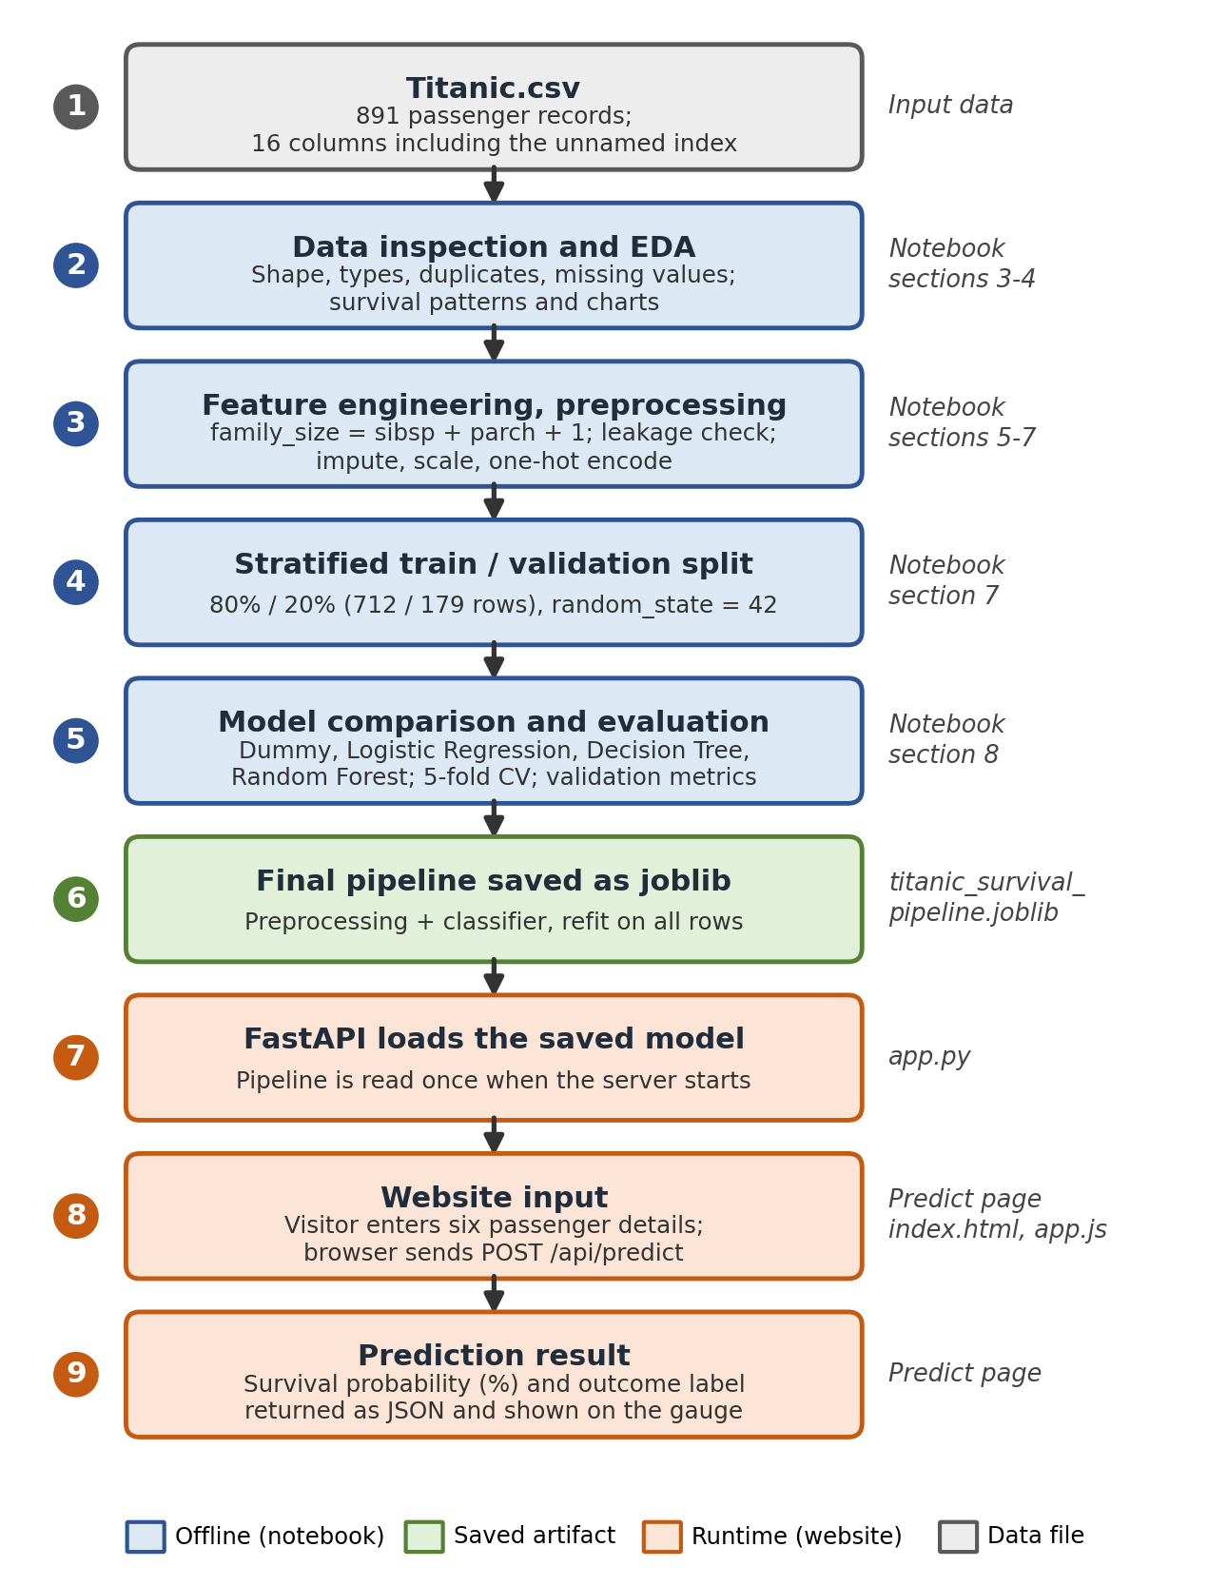

Figure 2: Project workflow from Titanic.csv to the prediction shown on the website.
Table 11: Workflow stages and where they are described.
Stage | Main output | Report section
1. Data and inspection | 891 validated records; index column removed | 4.1 to 4.3
2. EDA | Charts and observations | 4.4, 9.3
3. Features and preprocessing | family_size; leakage decisions; pipeline | 4.5 to 4.7
4. Stratified split | 712 training and 179 validation rows | 4.7
5. Model comparison | Cross-validation and validation results | 4.8, 9.5 to 9.7
6. Saved pipeline | titanic_survival_pipeline.joblib | 4.9
7 to 9. Website | API request, prediction and result display | 6

The two halves of the workflow are connected only through the saved pipeline file: the notebook writes it and the backend reads it. Any change to the preprocessing or model therefore requires re-running the notebook and restarting the server.

8. Program
This section shows the most relevant excerpts of the project code. The notebook excerpts are copied from Titanic_Survival_Analysis.ipynb and the front-end excerpt from static/app.js; they are not the complete files. Each listing is followed by a brief explanation.
Listing 1: Dropping the unnamed index column (notebook, section 3)
index_columns = [c for c in raw.columns if str(c).startswith("Unnamed")]
print("Unnamed columns found:", index_columns)

for col in index_columns:
is_row_number = bool((raw[col].to_numpy() == np.arange(len(raw))).all())
print(f"'{col}' is just the row number 0..{len(raw) - 1}: {is_row_number}")

# Remove it: a row number carries no information about the passenger.
df = raw.drop(columns=index_columns).copy()
The unnamed column is confirmed to be a plain row number and is removed so that it can never be used as a feature.
Listing 2: Feature engineering and feature sets (notebook, section 6)
df["family_size"] = df["sibsp"] + df["parch"] + 1
df["is_alone"] = (df["family_size"] == 1).astype(int)
df["family_group"] = pd.cut(df["family_size"], bins=[0, 1, 4, 20], labels=["Alone (1)", "Small (2-4)", "Large (5+)"])

BASELINE_FEATURES = ["pclass", "sex", "age", "sibsp", "parch", "fare", "embarked"]
ENGINEERED_FEATURES = ["pclass", "sex", "age", "family_size", "fare", "embarked"] # same as the website inputs
family_size is created from sibsp and parch. The engineered feature list is identical to the six inputs expected by the website.
Listing 3: Preprocessing and model pipeline (notebook, section 7)
def build_preprocessor(numeric_features, categorical_features):
numeric_steps = Pipeline([
("impute", SimpleImputer(strategy="median")),
("scale", StandardScaler()),
])
categorical_steps = Pipeline([
("impute", SimpleImputer(strategy="most_frequent")),
("onehot", OneHotEncoder(handle_unknown="ignore", sparse_output=False)),
])
return ColumnTransformer([
("num", numeric_steps, numeric_features),
("cat", categorical_steps, categorical_features),
])

def make_pipeline(model, numeric_features, categorical_features):
return Pipeline([
("preprocess", build_preprocessor(numeric_features, categorical_features)),
("model", model),
])
Numeric columns are median-imputed and standardised; categorical columns are mode-imputed and one-hot encoded. Wrapping this in a Pipeline guarantees that the same steps run during training and prediction.
Listing 4: Stratified train/validation split (notebook, section 7)
train_df, valid_df = train_test_split(
df, test_size=0.20, stratify=df[TARGET], random_state=RANDOM_STATE
)
y_train, y_valid = train_df[TARGET], valid_df[TARGET]
The split happens before any preprocessing is fitted. stratify keeps the survival proportion nearly equal in both parts, and random_state makes the split reproducible.
Listing 5: Cross-validation and hyperparameter search on training data (notebook, section 8)
cv = StratifiedKFold(n_splits=5, shuffle=True, random_state=RANDOM_STATE)

cv_scoring = {
"accuracy": "accuracy",
"precision": make_scorer(precision_score, zero_division=0),
"recall": make_scorer(recall_score, zero_division=0),
"f1": make_scorer(f1_score, zero_division=0),
"roc_auc": "roc_auc",
}

def cross_validated_scores(pipeline, X, y):
results = cross_validate(pipeline, X, y, cv=cv, scoring=cv_scoring)
return {name: results[f"test_{name}"].mean() for name in cv_scoring}

# ... (search_setup holds a small parameter grid per model) ...
for name, (model, grid) in search_setup.items():
pipe = make_pipeline(model, NUMERIC_ENGINEERED, CATEGORICAL_ENGINEERED)
search = GridSearchCV(pipe, grid, scoring="roc_auc", cv=cv, n_jobs=-1)
search.fit(X_train, y_train)
fitted_models[name] = search.best_estimator_
tuning_rows.append({
"Model": name,
"Best settings": {k.replace("model__", ""): v for k, v in search.best_params_.items()},
"CV ROC-AUC": round(search.best_score_, 3),
})
Model settings are chosen by 5-fold stratified cross-validation on the training rows only. The validation rows are not touched in this step.
Listing 6: Validation-set evaluation function (notebook, section 8)
def evaluate(pipeline, X, y):
predictions = pipeline.predict(X)
probabilities = pipeline.predict_proba(X)[:, 1]
return {
"Accuracy": accuracy_score(y, predictions),
"Precision": precision_score(y, predictions, zero_division=0),
"Recall": recall_score(y, predictions, zero_division=0),
"F1": f1_score(y, predictions, zero_division=0),
"ROC-AUC": roc_auc_score(y, probabilities),
}
All five metrics are computed on the 20% of passengers that were not used for fitting or tuning.
Listing 7: Final fit, saving and reloading the pipeline (notebook, section 10)
# clone() copies the selected settings but starts untrained; we refit on ALL rows.
final_model = clone(selected_model).fit(df[WEBSITE_FEATURES], df[TARGET])
print("Final model:", selected_name)
print("Expected input columns:", WEBSITE_FEATURES)

MODEL_PATH = PROJECT_DIR / "titanic_survival_pipeline.joblib"
joblib.dump(final_model, MODEL_PATH)
print("Saved to:", MODEL_PATH)
# Verify: reload and confirm it gives the same answers
reloaded = joblib.load(MODEL_PATH)
same = np.allclose(reloaded.predict_proba(example_passengers), final_model.predict_proba(example_passengers))
print("Reloaded pipeline gives identical probabilities:", same)
The selected pipeline is refit on all rows for the interactive demo, saved with joblib as one object containing preprocessing and the classifier, then reloaded to confirm identical probabilities.
Listing 8: Front-end request to the prediction API (static/app.js)
const data = Object.fromEntries(new FormData(form).entries());
for (const key of ['pclass', 'age', 'family_size', 'fare']) data[key] = Number(data[key]);
try {
const response = await fetch('/api/predict', {
method: 'POST', headers: { 'Content-Type': 'application/json' }, body: JSON.stringify(data)
});
const result = await response.json();
// ... error handling omitted ...
const probability = result.survival_probability;
document.getElementById('score').textContent = `${probability}%`;
document.getElementById('gauge').style.setProperty('--score', probability);
document.getElementById('outcome').textContent = result.outcome;
The Predict page converts the numeric form fields and posts the six inputs as JSON to /api/predict. The excerpt is copied from app.js; the omitted line only handles error responses.

8.1 Backend Prediction Endpoint
[Insert the model-loading and POST /api/predict excerpts from app.py here.]
The file app.py was not available when this report was prepared, so its code is not reproduced and no backend code has been invented. The interface of the endpoints, as used by the front end and described in the README, is summarised below.

Table 12: API interface summarised from app.js, explore.js and the README.
Endpoint | Method | Request | Response fields used by the front end
/api/predict | POST | JSON: pclass, sex, age, family_size, fare, embarked | survival_probability (percent) and outcome; on error, detail[0].msg
/api/stats | GET | none | passengers, survived, not_survived, survival_rate, missing_age, by_class, by_sex, by_age, groups, missing_values

9. Results and Discussions
All results in this section were produced by running the notebook on Titanic.csv (software versions are listed in Appendix C). Validation results refer to the 179 passengers that were held out from training and tuning.

9.1 Dataset Overview and Target Distribution
Table 13: Dataset summary.
Item | Value
Passenger records | 891
Passenger columns (excluding index) | 15
Exact duplicate rows (kept) | 107
Survived (1) | 342 (38.4%)
Did not survive (0) | 549 (61.6%)
Training / validation rows | 712 / 179

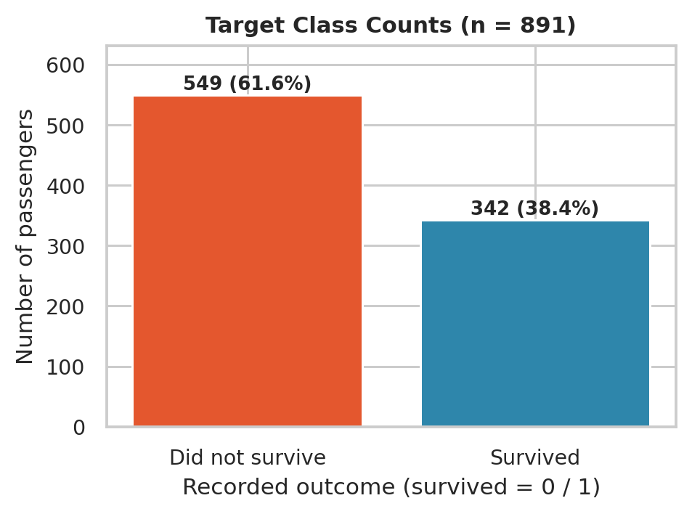
Figure 3: Number and percentage of passengers in each outcome class.
The classes are moderately imbalanced: 38.4% of passengers survived. A model that always predicts “did not survive” would already be correct for about 62% of passengers, which is why a baseline and several metrics are used.

9.2 Missing Values
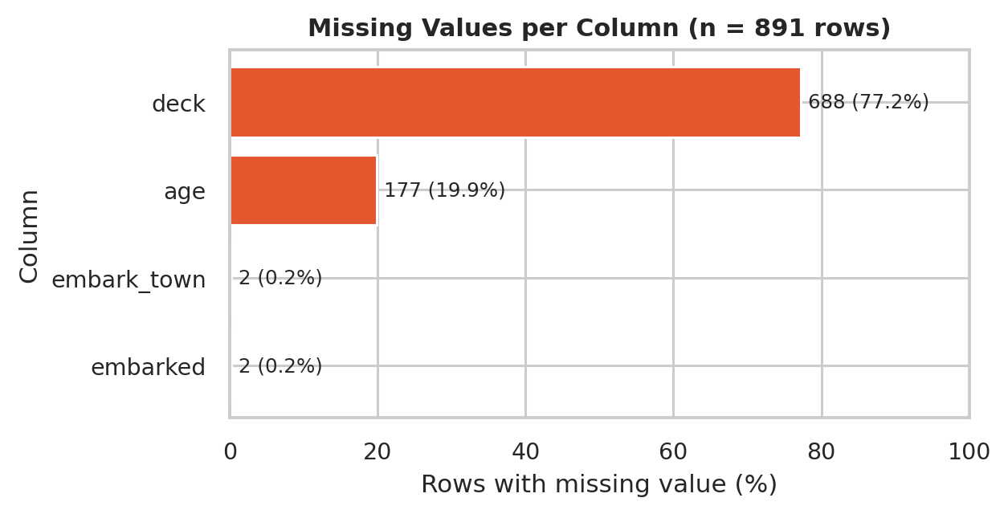
Figure 4: Percentage of rows with a missing value, by column.
age is missing for 177 passengers (19.9%), deck for 688 (77.2%), and embarked and embark_town for 2 passengers each. Age and embarkation port are imputed inside the pipeline; deck is not used because most of its values are absent.

9.3 Exploratory Data Analysis

Survival by sex and passenger class
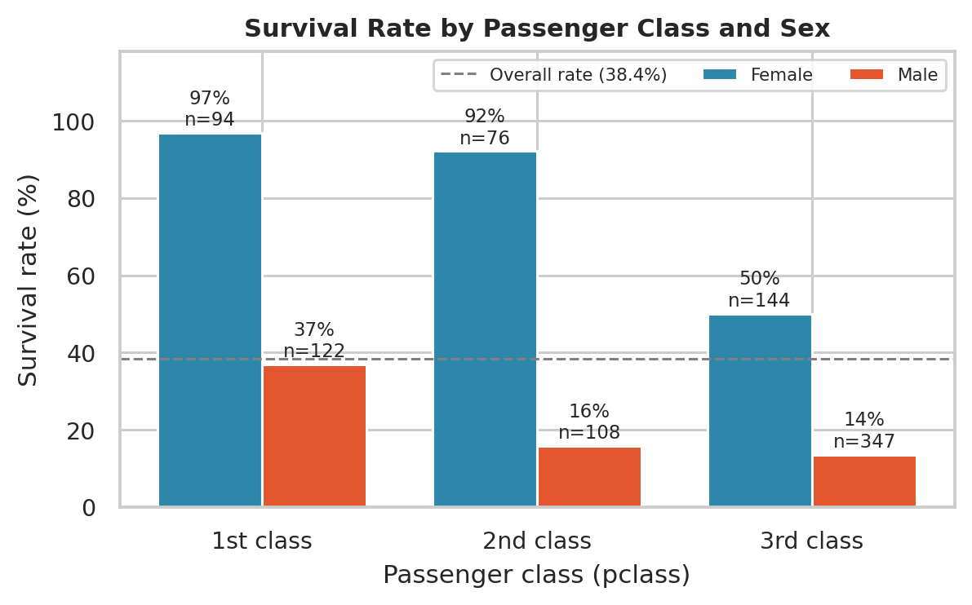
Figure 5: Survival rate by passenger class and sex. Labels show the rate and the group size (n).
Survival rates differ strongly by sex: 74.2% (n = 314) for women against 18.9% (n = 577) for men. By class, the rates are 63.0% (n = 216) in first class, 47.3% (n = 184) in second class and 24.2% (n = 491) in third class. The pattern holds within each sex: among women the rate falls from 96.8% in first class (n = 94) to 50.0% in third class (n = 144), and among men from 36.9% (n = 122) to 13.5% (n = 347).

Age
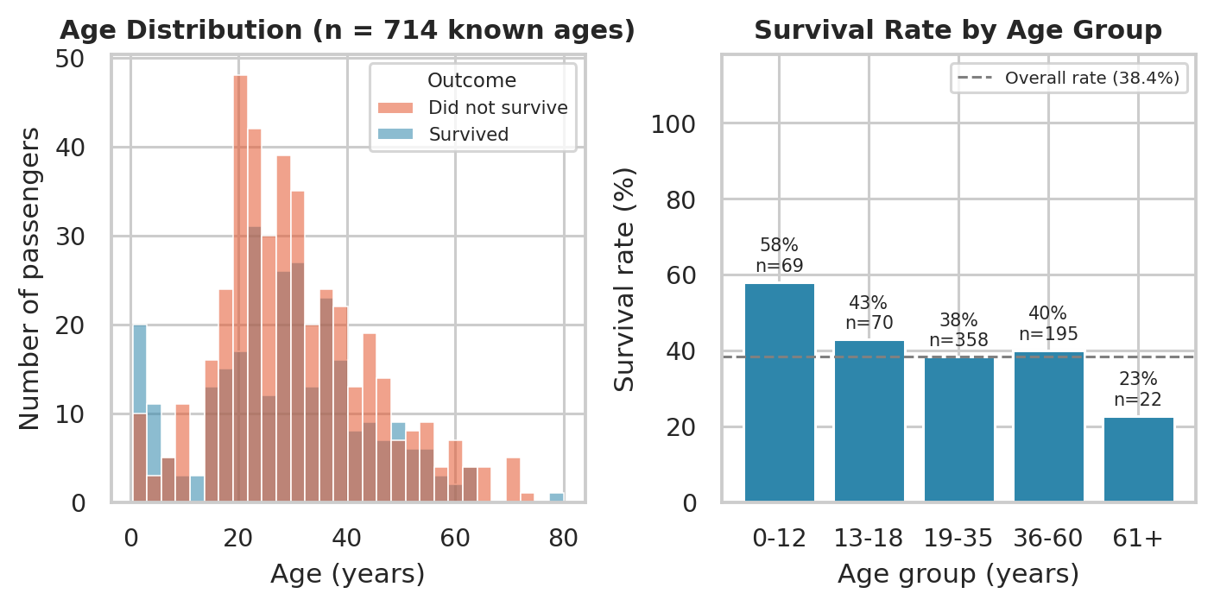
Figure 6: Age distribution by outcome (left) and survival rate by age group (right).
Age is known for 714 of 891 passengers. The youngest group (0 to 12 years) has the highest observed survival rate, 58.0% (n = 69), and the oldest group (61 and above) the lowest, 22.7% (n = 22). The oldest group is small, so its rate is less reliable than the rates of the large groups.

Fare
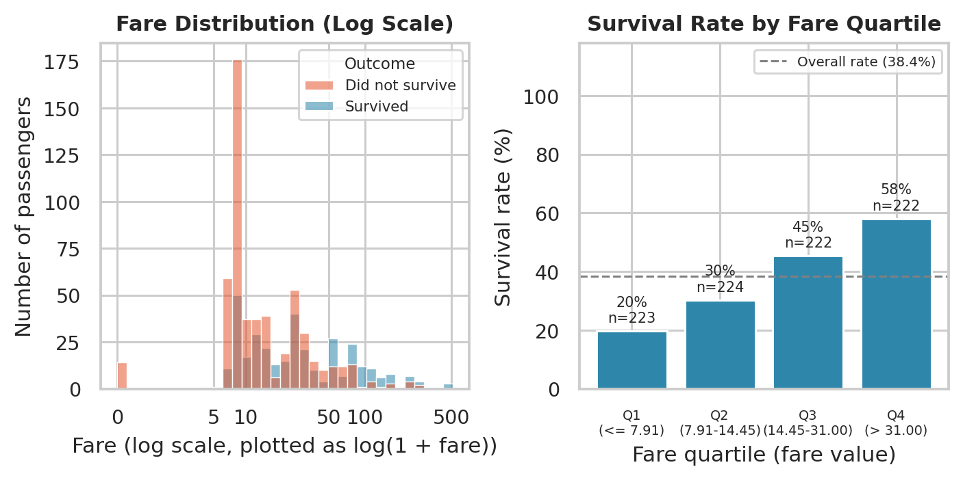
Figure 7: Fare distribution on a log scale (left) and survival rate by fare quartile (right).
Fares are strongly right-skewed (from 0 to 512.33), so a log scale is used to make the distribution readable; 15 passengers have a recorded fare of zero, which is why the transformation log(1 + fare) is used. Survival rises from 19.7% (n = 223) in the lowest fare quartile to 58.1% (n = 222) in the highest. Fare is closely tied to passenger class, so these two features carry overlapping information.

Embarkation port and family size
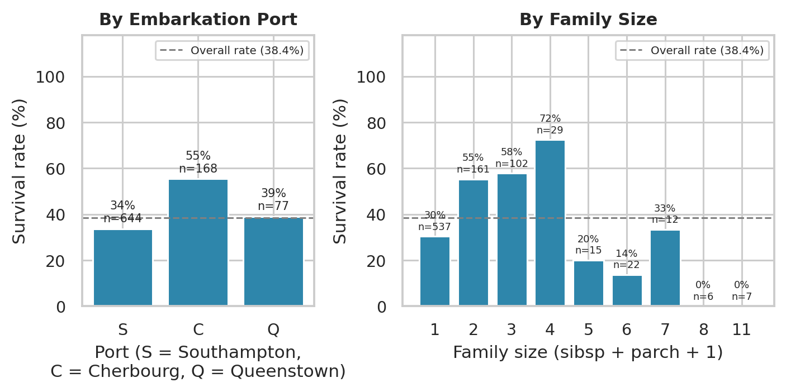
Figure 8: Survival rate by embarkation port (left) and by family size (right).
Observed survival is 55.4% (n = 168) for Cherbourg, 39.0% (n = 77) for Queenstown and 33.7% (n = 644) for Southampton. By family group, passengers travelling alone have 30.4% (n = 537), small families (2 to 4 people) 57.9% (n = 292) and large families (5 or more) 16.1% (n = 62). Several large family sizes contain only a handful of passengers, so their individual bars should be read with caution.
Caveat for all EDA charts: these are descriptive associations in one historical dataset. Sex, class, fare and embarkation port are related to one another, so a pattern in one variable can partly reflect another; the charts do not show that any variable caused survival. Age is missing for about one in five passengers, and those passengers may differ from the rest.

9.4 Baseline versus Engineered Features
Table 14: Mean 5-fold cross-validation scores on the training data for the two feature sets.
Model | Baseline: CV F1 | Baseline: CV ROC-AUC | Engineered: CV F1 | Engineered: CV ROC-AUC
Logistic Regression | 0.730 | 0.853 | 0.729 | 0.854
Decision Tree | 0.730 | 0.854 | 0.728 | 0.854
Random Forest | 0.733 | 0.863 | 0.734 | 0.867

Replacing sibsp and parch with family_size changes the cross-validated ROC-AUC by at most 0.004 for any model. The engineered feature therefore describes the same information more simply, without a meaningful loss, and it is also the input the website collects. Differences this small are within normal cross-validation noise.

9.5 Cross-Validation of Models (Default Settings)
Table 15: Mean 5-fold cross-validation scores on the training rows, with initial model settings.
Model | Accuracy | Precision | Recall | F1 | ROC-AUC
Dummy baseline | 0.617 | 0.000 | 0.000 | 0.000 | 0.500
Logistic Regression | 0.802 | 0.768 | 0.696 | 0.729 | 0.854
Decision Tree | 0.815 | 0.833 | 0.652 | 0.728 | 0.854
Random Forest | 0.798 | 0.743 | 0.729 | 0.734 | 0.866

The Dummy baseline has zero precision, recall and F1, because it never predicts “survived”, and a ROC-AUC of 0.5, although its accuracy is not zero. All three real models clearly outperform it. The tuned cross-validation ROC-AUC values are given in Table 7 (Section 4.8).

9.6 Validation-Set Results
Table 16: Tuned models evaluated once on the 179 validation passengers (cut-off 0.5). The first numeric column is the cross-validation score on training data.
Model | CV ROC-AUC (train) | Accuracy | Precision | Recall | F1 | ROC-AUC
Dummy baseline | 0.500 | 0.615 | 0.000 | 0.000 | 0.000 | 0.500
Logistic Regression | 0.854 | 0.799 | 0.780 | 0.667 | 0.719 | 0.839
Decision Tree | 0.855 | 0.765 | 0.765 | 0.565 | 0.650 | 0.785
Random Forest | 0.878 | 0.799 | 0.811 | 0.623 | 0.705 | 0.833

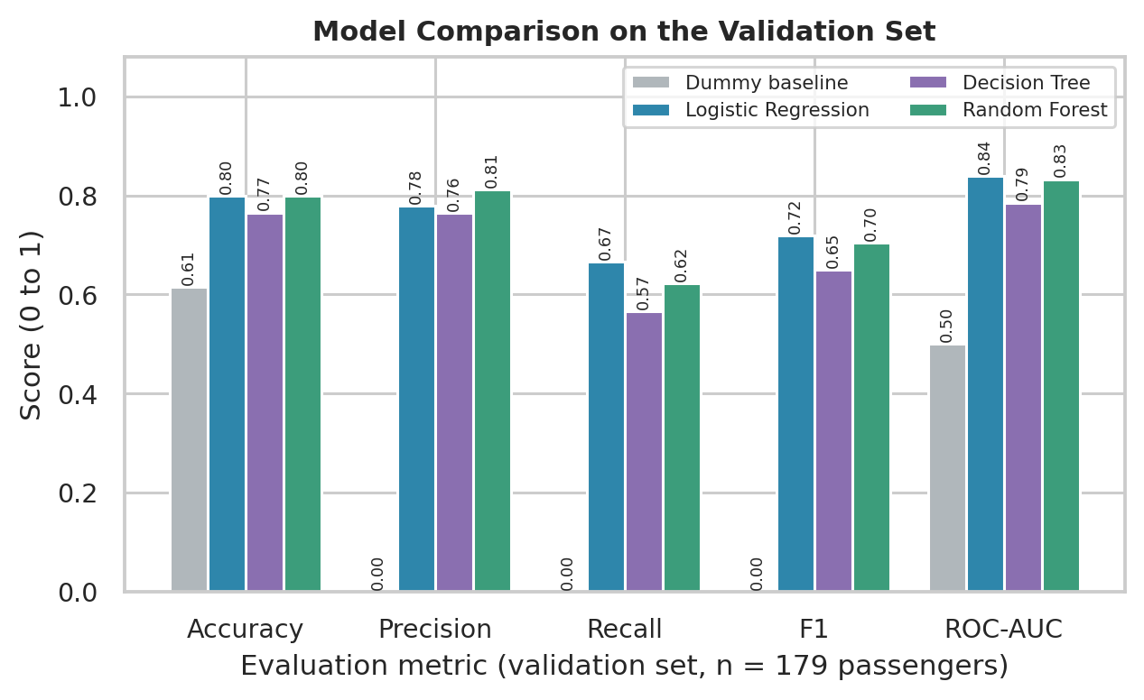
Figure 9: Comparison of all models on the validation set across five metrics.
On the validation set, Random Forest reaches an accuracy of 0.799, precision 0.811, recall 0.623, F1 0.705 and ROC-AUC 0.833. The Dummy baseline reaches an accuracy of 0.615 and ROC-AUC 0.500. Logistic Regression scores 0.799 accuracy, F1 0.719 and ROC-AUC 0.839; its ROC-AUC is 0.006 higher than the selected model, a difference that is too small to be meaningful with only 179 validation passengers. The Decision Tree is the weakest of the three real models (ROC-AUC 0.785).

9.7 Confusion Matrix and ROC Curves
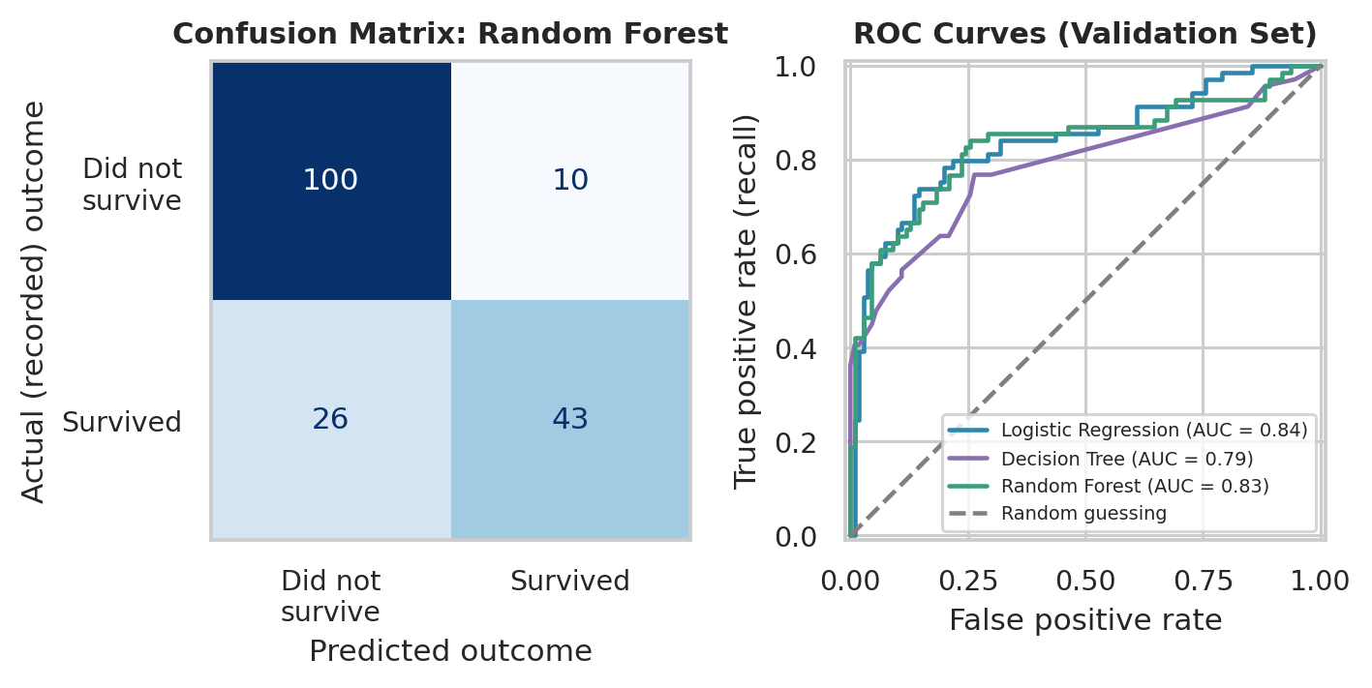
Figure 10: Confusion matrix of Random Forest on the validation set (left) and ROC curves of the tuned models (right).
Table 17: Confusion-matrix counts for Random Forest (total 179 passengers).
Cell | Meaning | Count
True negatives | Predicted did not survive; actually did not survive | 100
False positives | Predicted survived; actually did not survive | 10
False negatives | Predicted did not survive; actually survived | 26
True positives | Predicted survived; actually survived | 43

Of the 69 validation passengers who actually survived, the model identified 43 (recall 62.3%) and missed 26. Of the 53 passengers it predicted as survivors, 43 were correct (precision 81.1%). It correctly identified 100 of 110 non-survivors (90.9%). The model is therefore more cautious about predicting survival than about predicting non-survival. ROC curves that lie closer to the top-left corner indicate better ranking ability.

9.8 Model Interpretation
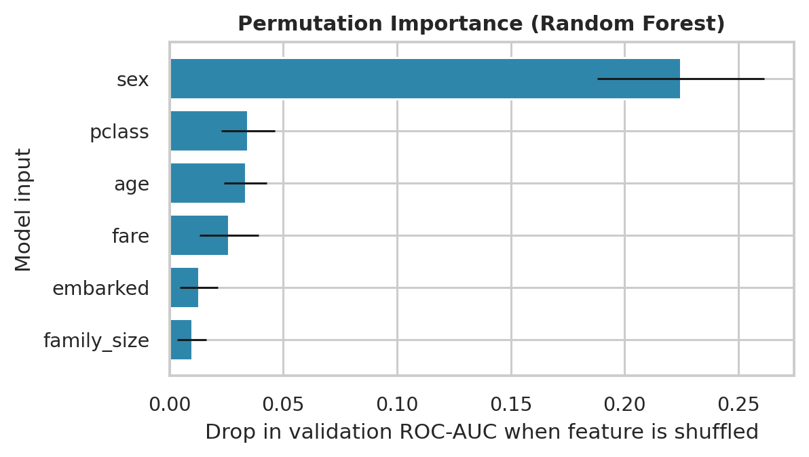
Figure 11: Permutation importance of the model inputs for Random Forest on the validation set.
Permutation importance shuffles one input at a time in the validation data and measures how much ROC-AUC drops; a larger drop means the model relies more on that input. sex shows by far the largest drop (0.225), followed by pclass (0.035), age (0.033) and fare (0.026). embarked and family_size have small effects with error bars that are comparable to their size.
Table 18: Coefficients of the tuned Logistic Regression (numeric features standardised). An odds ratio above 1 is associated with higher survival odds.
Feature (after encoding) | Coefficient | Odds ratio
sex_female | 1.37 | 3.95
pclass_1 | 1.03 | 2.80
embarked_Q | 0.34 | 1.40
pclass_2 | 0.14 | 1.15
fare | 0.14 | 1.15
embarked_C | 0.11 | 1.11
family_size | -0.27 | 0.76
embarked_S | -0.32 | 0.73
age | -0.48 | 0.62
pclass_3 | -1.05 | 0.35
sex_male | -1.25 | 0.29

The Logistic Regression coefficients give a second, simpler view that agrees in direction with the EDA, for example for sex_female and pclass_1 (positive) and sex_male and pclass_3 (negative). These are associations in historical data, not causes. The inputs overlap (fare and class, for example), so credit can be shared among them, and feature importance describes how the model behaves, not why a particular real passenger lived or died.

9.9 Behaviour of the Saved Model
The final pipeline was refit on all rows, saved, reloaded and used to estimate survival for example profiles. These values were computed by loading the pipeline directly in Python, not through the website.
Table 19: Example predictions from the saved pipeline (the first row uses the website's default form values, which are also used in the README example).
Profile | Class | Sex | Age | Family size | Fare | Port | Estimated survival | Predicted class
Website default | 1 | female | 28 | 2 | 72 | S | 99.4% | Survived
Example 2 | 1 | female | 28 | 1 | 80 | C | 99.5% | Survived
Example 3 | 3 | male | 30 | 1 | 8.05 | S | 14.3% | Did not survive
Example 4 | 2 | male | 8 | 4 | 30 | S | 70.2% | Survived

Probabilities near 0% or 100% should not be read as certainty. Tree-based models can produce very confident-looking values because their probabilities are not calibrated, and the demo model has been fitted on every available record.

9.10 Discussion
- Validation versus demo model. The validation scores come from a model trained on 712 rows and tested on 179 unseen rows; this is the honest estimate of performance. The saved demo model is refit on all 891 rows, so it cannot be scored on unseen data and its displayed probability is not a test score.
- Cross-validation versus validation. The tuned models' cross-validation ROC-AUC (for example 0.878 for Random Forest) is higher than their validation ROC-AUC (0.833). This is expected: settings were chosen as the best of many tries, so the cross-validation score is slightly optimistic, whereas the validation set was never used for choosing.
- Small validation set. With 179 validation passengers, one split is noisy. The gap between Logistic Regression and Random Forest is within that noise, and the ranking could change with a different split.
- Beyond the baseline. All real models clearly outperform the no-skill baseline (accuracy 0.615), but about 38% of actual survivors in the validation set are still missed by Random Forest, so the model is far from perfect.
- Explanatory power. The strongest patterns (sex and passenger class) are visible in both the EDA and the model, which is reassuring, but the data contain no information on circumstances such as location on the ship or access to lifeboats.

10. Snippets of UI
The website has three pages that share a common header and navigation bar. The screenshots below must be captured from the running application. They have been left as clearly marked placeholders because the application could not be run while this report was prepared, and mock-ups are deliberately not used in place of real screenshots.

10.1 Predict Page
Figure 12: Predict page (screenshot to be inserted).
SCREENSHOT PLACEHOLDER
[Insert screenshot of http://127.0.0.1:8000/predict]

The Predict page contains a hero section with generated artwork, the passenger profile form (ticket class, sex, age, family group size, fare and embarkation town), a likelihood gauge with the outcome label and an explanatory note, three small charts of survival rate by ticket class, sex and age group, a dataset summary strip, and a short project description. On load, the page runs one prediction using the default form values.

10.2 Explore Data Page
Figure 13: Explore data page (screenshot to be inserted).
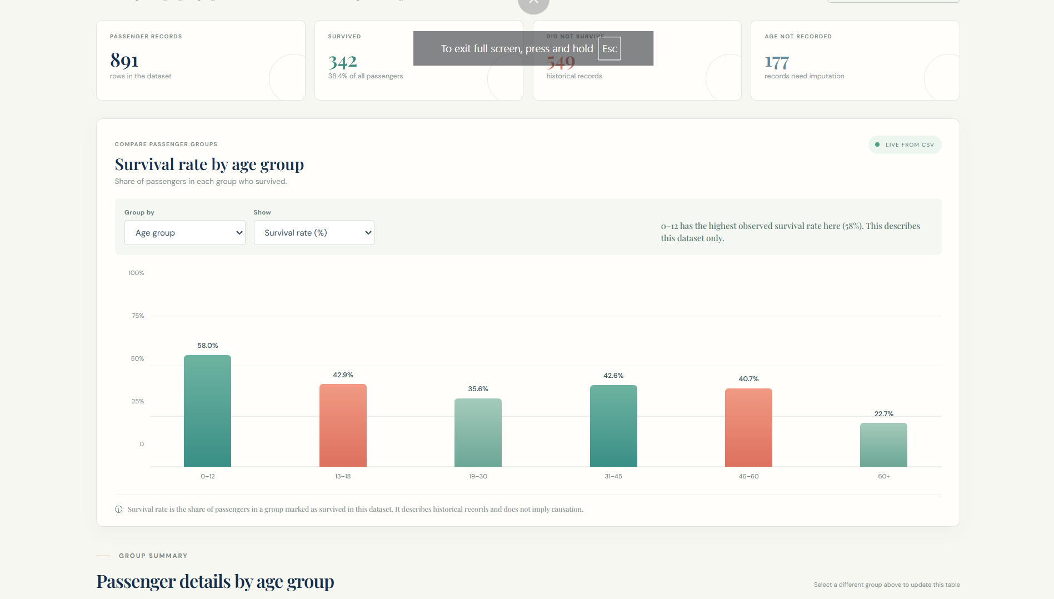

The Explore page shows four summary cards, an interactive chart whose grouping and measure can be changed with two drop-down menus, a group summary table, a missing-value panel, and a field guide with a search box that highlights which columns are model inputs and which are excluded.

10.3 About Page
Figure 14: About page (screenshot to be inserted).


The About page explains the project, the model pipeline steps, the six model inputs, and how to read the result, using expandable notes. A button links back to the predictor.

10.4 Screenshot Checklist and Note on the Artwork
Table 20: Screenshots to be captured (server started with python -m uvicorn app:app --reload).
Figure | Page / address | What to capture
Predict | /predict | Full page after load, showing the form, gauge and result for the default profile; optionally a second capture with another profile.
Explore data | /explore | Summary cards and the interactive chart; optionally a capture with a different grouping selected.
About | /about | Pipeline steps and the expanded notes section.

The ship image used in the hero sections is generated, illustrative artwork of a Titanic-style ocean liner. According to the project README it is not an archival photograph, and it should not be presented as one.

11. Future Scope
The following improvements are proposed future work. None of them is implemented in the current project.
- Stronger validation: repeat the evaluation with several random splits or repeated cross-validation, and use nested cross-validation when tuning, to measure how stable the results are.
- Probability calibration: assess and, if needed, calibrate the predicted probabilities so that they can be compared with observed survival rates.
- Further explainability: add explanations for individual predictions and clearer on-page descriptions of which inputs drive an estimate, while keeping the association-versus-causation caveat.
- Threshold analysis: study how changing the 0.5 cut-off trades precision against recall.
- Model information on the website: expose the name and validation scores of the loaded model through the API, so that the website text always matches the saved model.
- Accessibility: provide text alternatives or data tables for the custom charts, verify keyboard navigation and colour contrast, and test with screen readers.
- Responsive design: test and refine the layouts on additional screen sizes and devices.
- Testing and deployment: add automated tests for the API and pipeline, pin and verify dependency versions, and deploy the application to a hosting platform.

12. Conclusion
This project built a complete, beginner-friendly machine learning workflow for estimating the recorded survival outcome of Titanic passengers. The dataset of 891 records was validated, explored and prepared using leak-free scikit-learn pipelines; the target-leaking column alive and several redundant or derived columns were excluded; and the feature family_size was engineered. A no-skill baseline, Logistic Regression, a Decision Tree and a Random Forest were compared with cross-validation on the training data and evaluated once on a stratified validation set. Random Forest was selected by the cross-validation rule and reached an accuracy of 0.799 and ROC-AUC of 0.833 on the validation set, clearly better than the baseline (accuracy 0.615, ROC-AUC 0.500), although Logistic Regression performed about as well. A complete preprocessing-plus-model pipeline was saved with joblib and connected to a FastAPI website with Predict, Explore data and About pages.
Key lessons from the project include the importance of splitting data before fitting any preprocessing, of identifying leakage explicitly, of comparing against a baseline, and of reporting uncertainty honestly.

12.1 Limitations
- Historical data. The results describe one historical file. The file does not cover everyone aboard, and the findings do not transfer to other events.
- Missing values. Age is missing for 19.9% of passengers and is imputed with the training median, which may blur real differences.
- Small sample. With 179 validation passengers, scores vary with the split, and small differences between models are not meaningful.
- Model uncertainty. Predictions are estimates, not guarantees, and probabilities from tree-based models may not be calibrated.
- Association, not causation. Importance and coefficients show what is useful for prediction, not what caused survival; many real-world factors are absent from the data.
- Validation versus demo. The validation metrics describe a model trained on 80% of the rows. The website uses a model refit on all rows, whose displayed probability is not a held-out score.
- Real individuals. The model cannot determine what would actually have happened to a real person.

References
[1] D. R. Cox, “The regression analysis of binary sequences,” Journal of the Royal Statistical Society: Series B (Methodological), vol. 20, no. 2, pp. 215–242, 1958.
[2] L. Breiman, J. H. Friedman, R. A. Olshen and C. J. Stone, Classification and Regression Trees. Belmont, CA, USA: Wadsworth, 1984.
[3] L. Breiman, “Random forests,” Machine Learning, vol. 45, no. 1, pp. 5–32, 2001. doi: 10.1023/A:1010933404324.
[4] T. Hastie, R. Tibshirani and J. Friedman, The Elements of Statistical Learning: Data Mining, Inference, and Prediction, 2nd ed. New York, NY, USA: Springer, 2009.
[5] L. Grinsztajn, E. Oyallon and G. Varoquaux, “Why do tree-based models still outperform deep learning on typical tabular data?,” in Advances in Neural Information Processing Systems 35 (NeurIPS 2022), 2022. arXiv:2207.08815. https://arxiv.org/abs/2207.08815
[6] S. Kaufman, S. Rosset, C. Perlich and O. Stitelman, “Leakage in data mining: Formulation, detection, and avoidance,” ACM Transactions on Knowledge Discovery from Data, vol. 6, no. 4, Art. 15, Dec. 2012. doi: 10.1145/2382577.2382579.
[7] T. Fawcett, “An introduction to ROC analysis,” Pattern Recognition Letters, vol. 27, no. 8, pp. 861–874, 2006. doi: 10.1016/j.patrec.2005.10.010.
[8] F. Pedregosa et al., “Scikit-learn: Machine learning in Python,” Journal of Machine Learning Research, vol. 12, pp. 2825–2830, 2011.
[9] FastAPI documentation. https://fastapi.tiangolo.com/ (accessed [access date]).
[10] scikit-learn User Guide. https://scikit-learn.org/stable/user_guide.html (accessed [access date]).

Appendices

Appendix A: Running the Project (from the project README)
Open PowerShell in the project folder (Windows) and run:
python -m venv .venv
.\.venv\Scripts\Activate.ps1
python -m pip install -r requirements.txt
python -m uvicorn app:app --reload
Then open http://127.0.0.1:8000 in a browser. The README requires Python 3.10 or newer. To create the saved model, open Titanic_Survival_Analysis.ipynb in VS Code (with the Python and Jupyter extensions), choose the .venv kernel and use Run All.

Appendix B: Example API Request (from the project README)
Invoke-RestMethod -Method Post -Uri http://127.0.0.1:8000/api/predict `
-ContentType 'application/json' `
-Body '{"pclass":1,"sex":"female","age":28,"family_size":2,"fare":72,"embarked":"S"}'
For this input, loading the saved pipeline directly in Python gives an estimated survival probability of 99.4% (see Table 19 in Section 9.9).

Appendix C: Software Environment Used for the Reported Results
Table 21: Library versions used to generate the results in this report.
Software | Version
Python | 3.12.3
scikit-learn | 1.8.0
pandas | 3.0.2
NumPy | 2.4.4
Matplotlib | 3.10.8

The README states that the notebook's scikit-learn version is pinned in requirements.txt

